H3 - Nose sweeps are not spatially enriched in odor-reached regions beyond occupancy
Nose-Sweeps & Odor-Guided Search | Hypothesis 3 report
VERDICT: H3 is NOT supported (null result). Nose sweeps track where the animal spends time (occupancy), not odor-reached regions specifically.

1. Goal and hypotheses
H3 asks whether nose sweeps are spatially enriched in odor-reached regions of the arena beyond what the animal's occupancy alone would predict. If sweeps are an odor-guided search behavior, they should concentrate in bins the odor plume has reached, over and above the time the animal spends there.
Hypotheses (direction reported before significance; nulls headlined):
- H3 (alternative): f_sweep > f_occ - the fraction of sweeps landing in odor-reached bins exceeds the fraction of all kept head frames in those bins (spatial enrichment beyond occupancy).
- H0 (null): f_sweep = f_occ - sweeps are distributed across odor-reached bins in proportion to occupancy (no enrichment).

2. Methods
Pipeline and library.
All quantities were computed on the head clock via the accessor and the shared library reactions_common (which imports plume_common), reusing the advancing-reference de-jump cleaning, head-clock interpolation, and velocity/R machinery. Version tag reactions_common/1.0. Interpreter: the project virtual environment python (vras). Random seed 1234 throughout. Results object created 2026-08-08T19:35:19Z.
Odor-reached definition (D9).
A bin is 'odor-reached' if, in the reused per-location odor field (Plume locations/data/odor_fields.h5, read-only), that bin has a valid distinct-trial count >= 3 AND a maximum field value > 0.001 (the odor-field cutoff). The cutoff sits above the deconvolution noise floor (~0.0004); mapped-bin ethanol is above the noise floor, so 'odor-reached' bins reflect real signal rather than noise.
Per-trial statistics.
- f_sweep = fraction of a trial's detected sweep peaks that fall in odor-reached bins.
- f_occ = fraction of all kept head frames (occupancy) in that trial that fall in odor-reached bins.
- Within-trial permutation null: draw n_sweeps random frame times (2000 draws per trial, seed 1234); the per-trial statistic is f_sweep - mean(null).
Inference.
Unit of analysis = trial. Pooled sample = Loc1-6, n = 105 trials (of 114 processed; anotherLoc analysed separately and excluded, D10). Two paired/one-sided Wilcoxon signed-rank tests: (i) f_sweep > f_occ, and (ii) f_sweep - mean(null) > 0. Per-test statistics; no family-wise correction across H1-H3.

3. Results
H3 is not supported. Across the 105 pooled trials, the median fraction of sweeps in odor-reached bins (f_sweep = 0.336) is essentially equal to - and in fact slightly below - the median occupancy fraction in those bins (f_occ = 0.349). The direction of the effect is therefore against enrichment.
The one-sided Wilcoxon test for enrichment beyond occupancy (f_sweep > f_occ) is not significant: W = 3107.0, p = 0.150. The complementary test against the within-trial permutation null (f_sweep - mean(null) > 0) is likewise not significant: W = 3123.0, p = 0.138.
Only 0.543 of trials (54.3%) show f_sweep exceeding their occupancy-matched expectation - close to the ~50% expected by chance. Taken together: sweeps land in odor-reached bins about as often as the animal simply happens to be there. Sweeps track occupancy, not odor-reached regions specifically.
Summary of H3 statistics (injected from stats.json):
Quantity | Value
Median f_sweep (sweeps in odor-reached bins) | 0.336
Median f_occ (occupancy in odor-reached bins) | 0.349
Direction | f_sweep < f_occ (against enrichment)
Wilcoxon f_sweep > f_occ: statistic | 3107.0
Wilcoxon f_sweep > f_occ: p-value | 0.150
Wilcoxon f_sweep - mean(null) > 0: statistic | 3123.0
Wilcoxon f_sweep - mean(null) > 0: p-value | 0.138
Fraction of trials enriched | 0.543
Odor-field cutoff | 0.001
Permutation draws / trial | 2000
Unit of analysis / n | trial / 105 (pooled Loc1-6)

Figure 3.
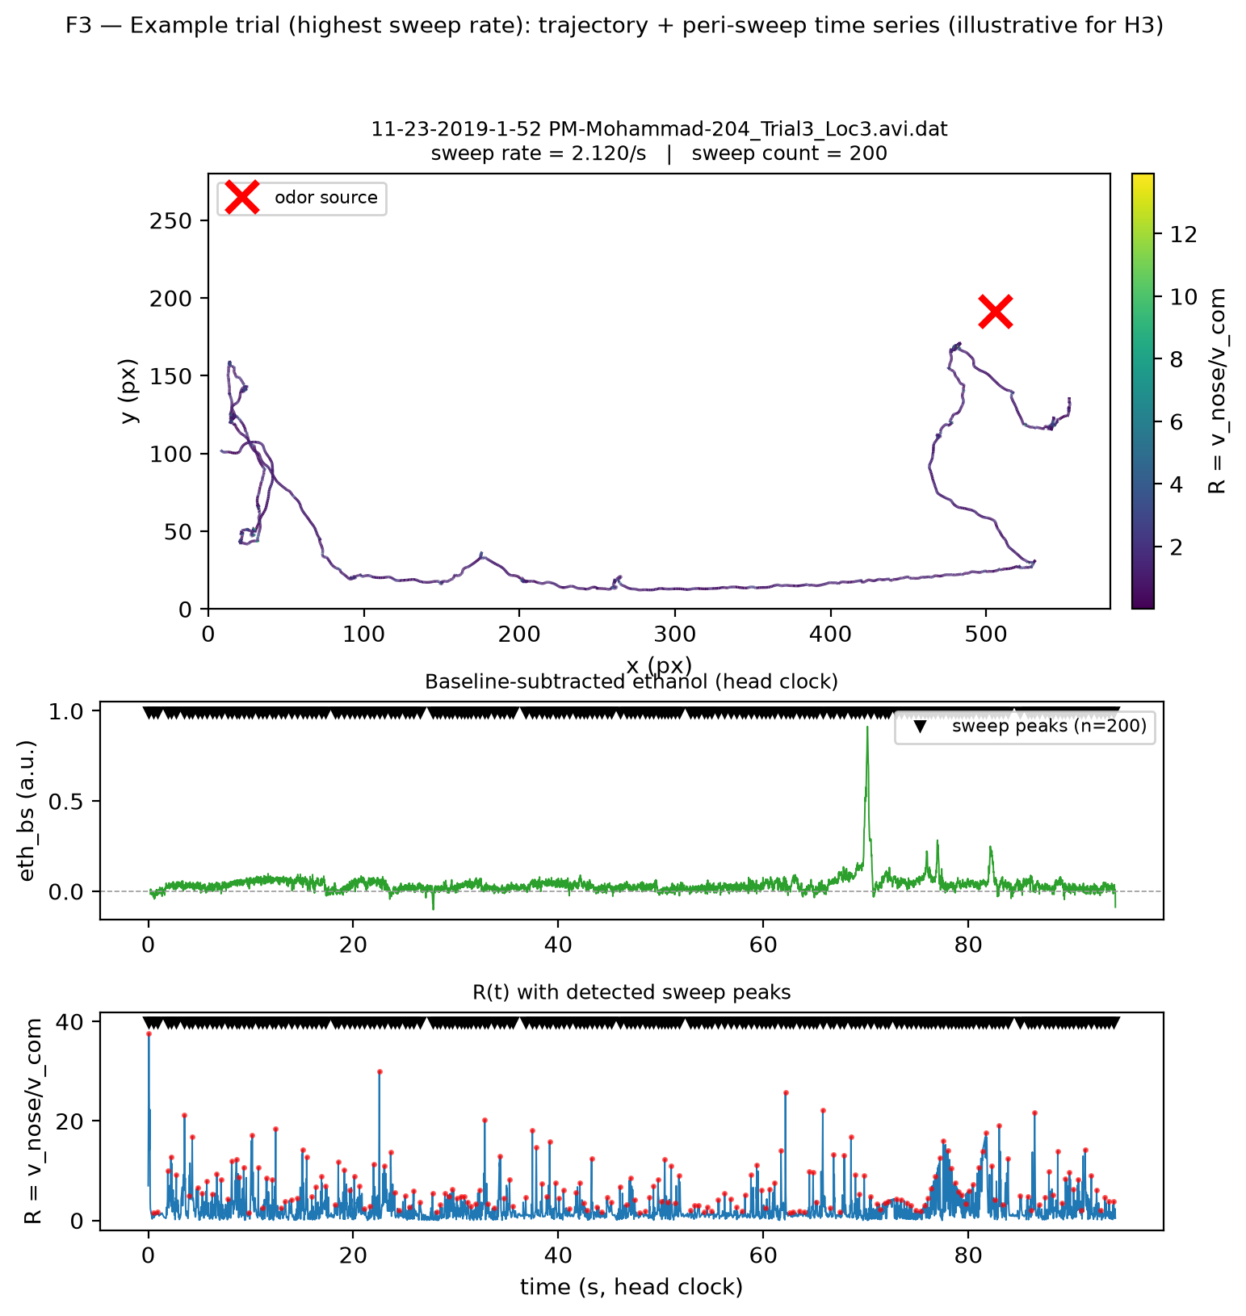
Figure 3 (illustrative for H3). Example trial with the highest pooled sweep rate: 11-23-2019-1-52 PM-Mohammad-204_Trial3_Loc3.avi.dat (Loc3, trial index 37; sweep rate 2.120/s, 200 sweeps). (A) Center-of-mass (body) trajectory within the arena box [0,580] x [0,280] px, equal aspect, colored by R = v_nose/v_com; the red x marks the odor source endpoint. (B) Two stacked time series on the head clock: (i) baseline-subtracted ethanol (a.u.) and (ii) R(t), with markers at the detected sweep-peak times (identical event times in both panels). This single-trial example is illustrative only; the H3 verdict rests on the pooled statistics above, which do not support enrichment.

4. Caveats
- Sweeps track occupancy. The near-identity of f_sweep and f_occ (with f_sweep marginally lower) indicates sweeps are distributed like time spent, not preferentially in odor-reached bins. This is the honest, direction-first reading: the point estimate favors the null.
- Reused odor field. Odor-reached bins come from a per-location odor field aggregated across trials (reused from the Plume-locations analysis), not a per-trial plume map; this smooths over trial-to-trial plume variability.
- Single cohort / infrared / pixels. One imaging cohort, infrared tracking, spatial units in pixels; no cross-cohort replication.
- Direction before significance. Even setting aside the non-significant p-values (p = 0.150 and p = 0.138), the effect direction and the near-chance enriched-trial fraction (0.543) argue against H3 on their own.
- Detector threshold. Sweep detection is threshold-dependent and many detected sweeps are routine nose motion; the odor-field cutoff (0.001) is above the deconvolution noise floor (~0.0004), so mapped-bin ethanol reflects real signal.

5. Reproducibility
All numbers above are injected from the saved results object; nothing was recomputed or hand-typed in this report.
Result files:
- data\stats.json (H3 block, F3_example, meta)
- data\sweeps.h5 (/trials/<idx> per-frame arrays; /sweeps per-sweep table)
- reports\figures\F3_example_trajectory_and_timeseries.{png,pdf,txt}
Regenerate the figure and this report (project interpreter; headless Agg):
"C:/Projects/Repos/Agentic Research/Research Setup/vras/Scripts/python.exe" code\make_F3.py
"C:/Projects/Repos/Agentic Research/Research Setup/vras/Scripts/python.exe" code\make_H3_report.py
Seed 1234; permutation draws 2000; pooled n = 105 (Loc1-6); library reactions_common/1.0; results created 2026-08-08T19:35:19Z.

